checklist for things that are surprisingly colorable in 1.9
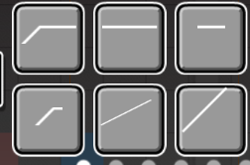
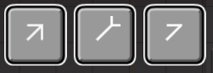



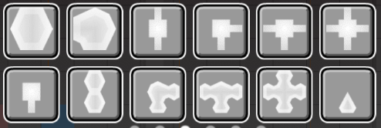
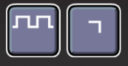

special attention to:
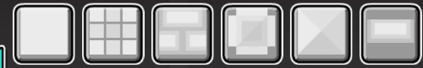

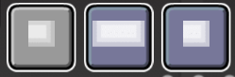

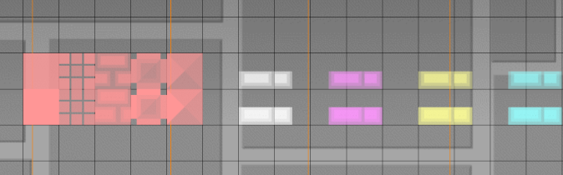

цвета каналов:
Default = FFFFFF (255, 255, 255)
Col1 = FF96FF (255, 150, 255)
Col2 = FFFF96 (255, 255, 150)
Col3 = 96FFFF (150, 255, 255)
Col4 = 96FF96 (150, 255, 150)
P1 = AF96FF (175, 150, 255)
P2 = FF9696 (255, 150, 150)
LBG = 4BAFFF (75, 175, 255)

OBJ = FFFFFF (255, 255, 255)
3DL = FFFF00 (255, 255, 0)

